Berita Bethel

of K.C. UNG

For Private Circulation Only Vol. 12 No. 2 (June 2008 from March. 2008)
ΦΦΦΦΦΦΦΦΦΦΦΦΦΦΦΦΦΦΦΦΦΦΦΦΦΦΦΦΦΦΦΦΦΦΦΦΦΦΦΦΦΦΦΦΦΦΦΦΦΦΦΦΦΦΦΦΦΦΦΦΦΦΦΦ
My Faithful prayer partner/s in the Faith and in the defence of the Gospel (Phil. 1:5, 7)
ΦΦΦΦΦΦΦΦΦΦΦΦΦΦΦΦΦΦΦΦΦΦΦΦΦΦΦΦΦΦΦΦΦΦΦΦΦΦΦΦΦΦΦΦΦΦΦΦΦΦΦΦΦΦΦΦΦΦΦΦΦΦΦ

Dates Diary
I keep a Dates Diary with over 500 entries of important birthdays, deaths, anniversaries (weddings, historical events, etc.) of all sorts. Every month I would extract the relevant ones out, for me to act on, in sending greetings, condolences, congratulations and messages to those concerned by phone, SMS or email. Thus, when 1st May dawned, one entry stood out among others:

May 25 | Anniversary | Burmah Road Gospel Hall (BRGH) | 1938

It was the 70th Anniversary of my home assembly on 25th May. It was therefore no accident that I remembered that date so well as I had highlighted and crafted it into my memory anticipating it eagerly. On 18th May, at the Penang Assembly Partnership meeting at Sungei Nibong Gospel Hall where Penang assembly leaders met, I saw bro. Joseph Lim, the only BRGH representative at the meeting and reminded him of this important date. Good for him that earlier he had visited my website and had taken cognizance of it too. However, when asked if BRGH was doing anything to celebrate the occasion, he was not aware of it. At that time, there was also unofficial news that the new building plans for BRGH had been approved by the authorities, and I told him that he should not let such an important occasion just pass by – Approval of the building plans on the 70th Anniversary of BRGH! God’s timing was perfect. Good for him again, that he acted and got the agreement and approval of the oversight to hold a two-fold private thanksgiving celebration on 25th May morning. You may like to visit http://picasaweb.google.com/beritabethelung/BRGH70thAnniversary?authkey=r9r31UYHxXM to view the photos (courtesy of bro. Kenneth Oh) .
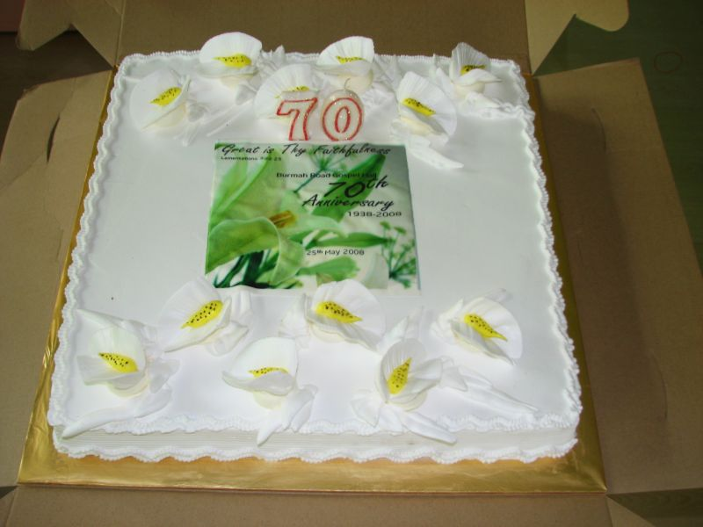

[Note: For those interested to read
the Pictorial History of Farquhar Street Mission House and Chapel, visit: http://www.berita-bethel-ung.com/webcontent/farquhar%20st%20mission%20hse%20&%20chapel.html
For the corresponding written historical record "Understanding the History and Heritage of our Assembly" (which includes BRGH history) from 25th May 1938 – 25th May 1998 click inside the given link in the document above.]
For me May 25th was a glad and sad day. Glad because the saints at BRGH got to celebrate and remember the occasion on that 25th May morning and also to give thanks to God for the approval of the building plans which was officially passed on 9th May.

Yet I was sad, because I did not get to rejoice with them in person. I was at Bidor Gospel Centre teaching on Habakkuk then. Unless the celebration was held in the evening when I could be back, a very rare opportunity as I seldom got to be free on a Sunday night when out ministering the Word. However, that was not to be, and the best I could do was to be with the saints at BRGH in spirit and to send them a congratulatory message for the occasion. (See Appendix)

Anniversaries
Are Anniversaries important? To some, such days pass without any fuss. What’s the big deal about them? – so they asked.

Yet God ordered Israel to celebrate the annual Passover to keep in remembrance their deliverance from Egypt and to pass this down as “inheritance” from generation to generation: And this day shall be unto you for a memorial; and ye shall keep it a feast to the LORD throughout your generations; ye shall keep it a feast by an ordinance for ever. Exo. 12:14

Likewise, the yearly Feast of Purim was ever a reminder to the Jews of their narrow escape from being annihilated. The Jews ordained, and took upon them, and upon their seed, and upon all such as joined themselves unto them, so as it should not fail, that they would keep these two days according to their writing, and according to their appointed time every year;
And that these days should be remembered and kept throughout every generation, every family, every province, and every city; and that these days of Purim should not fail from among the Jews, nor the memorial of them perish from their seed. (Est. 9:27, 28)
Well, certainly there are the normal anniversaries and there are the special ones. And 70 is indeed special!
For a person to reach his/her 70th birthday is something to be thankful and grateful unto the Lord for. Seventy is the bound that God has set on human life (the days of our years are threescore years and ten – Psa. 90:10).
Beyond that is God’s bonus of blessings from day to day.

Apart from the 70th Anniversary of BRGH, there are two or perhaps three 70th birthdays I must mention. One is that of my dear compatriot of over 50 years of growing up together at BRGH and serving the Lord there, in Butterworth Gospel Hall and now at Sungei Nibong Gospel Hall. Bro Yun Wei Chin celebrated his 70th birthday in April at Equatorial Hotel. His four children invited his close friends for the occasion. If I understand correctly his wife, Leong Lai Wah will also have the same reason to thank the Lord this year. May the Lord bless this loving couple as they step into the bonus blessings of their bountiful Lord from this year onwards.

Another person whose two daughters remembered to celebrate their dad’s very important birthday was Mr. Soon Swee Kee, the oldest male member in BRGH. It was his 90th birthday and what a big occasion it was at Traders’ Hotel on April 12. Mr. Soon’s birthday actually was in January. He truly deserved it as he has been enjoying 20 bonus years of God’s blessings.

The oldest female member of BRGH is Mrs. Wu Cheong Teng who is two years short of a century this year. Next is Ms Martha Samuel who was born in April 1919. She too would join the ranks of Mr. Soon next year.

On July 10, Mr. and Mrs. Daniel Jevaraj will have much cause to thank the Lord – for their 10th Anniversary in commended service. They grew up in Taiping Gospel Hall, but had served the Lord in Burmah Road Gospel Hall, Butterworth Gospel Hall, Island Glades Gospel Centre and Sungai Nibong Gospel Hall whose saints finally commended then back to Taiping Gospel Hall. Surely they will be well remembered on their 10th Anniversary of commended service, having actually served the Lord for more than half a century before then.

While mentioning the above dear friends of mine, I would like to apologise to any I miss out for their important dates. And one that I almost leave out is my wife’s anniversary! For her, her three children and their spouses rallied round to fulfill her dream of a life-time – they sponsored her on a five-day cruise on Star Cruise Virgo in Hong Kong in April. I was privileged to tumpang her and thoroughly enjoyed the tour, though I had to work extra hard before and after the “relaxation and rest” to discharge all my commitments.

For our stay in Hong Kong before and after our cruise, we are greatly grateful to Kathy and Gladys Wong, the granddaughters of the late Mr. Ng Swee Sin, elder of Butterworth Gospel Hall with whom we served the Lord in the assembly there. The daughters inherited their mother’s hospitality and generosity, and their missionary father’s (in his seventies now and still very hale, hardy and healthy) fervency in the Lord’s service. We were the honoured recipients of their love, and as expressed by them, extended to us just as their mother would.
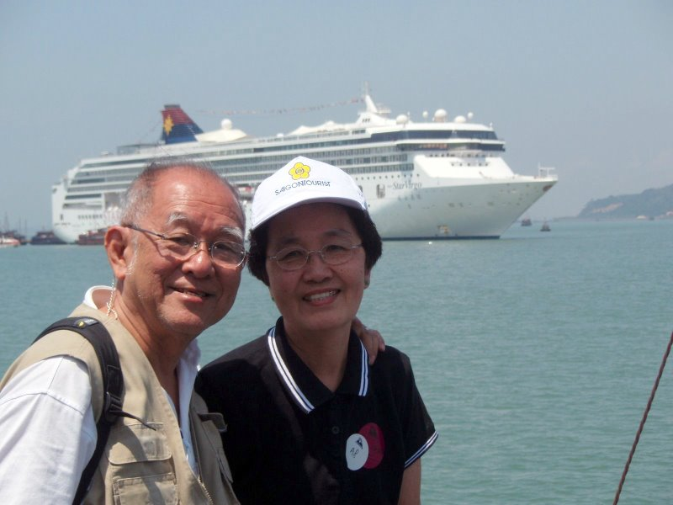
For those who want to see the 400 photos or so of this HK tour, you can email me for the URL to visit the site.
Ministries
Practically all of you are familiar with my teaching ministry to assemblies and I would like to thank each one for your fellowship in prayer and the practical partnership that comes with it. May the Lord make it up to you in a special way for your faithful fellowship and sacrifice.

Perhaps some of you may not be familiar with the other “hidden” or “behind the scene” ministries I am involved in. Very briefly they are…
- Pastoral Ministry – congratulating believers on their anniversaries as mentioned above by phone, SMS, and emailing; encouraging and comforting others who lose their loved ones or encounter sad news; giving an ear to those with problems, etc. If you desire to be part of this ministry please write in and let me know your important dates. “Rejoice with them that do rejoice, and weep with them that weep.”

- Writing Ministry –
  - Every Lord’s Day helping believers to prepare themselves for the Lord’s Supper with Ruminations for them to meditate on. These can also serve as sermonette outlines for expository study. You can access them by visiting:
http://www.berita-bethel-ung.com
or requesting for them to be sent to you by email attachment every week by Friday.
  - Every year contributing to the Choice Gleanings Daily Devotional Calendar published by the Gospel Folio Press, Ontario, Canada.
  - Recording historical events for posterity and saving them on my website http://www.berita-bethel-ung.com
My next project is to write a pictorial history of Burmah Road Gospel Hall from 1938 to 1998. The corresponding written history is already there. Hopefully, somebody in the know will take up the challenge to write an up-to-date history from 1998.
  - Answering believers’ questions and problems in their understanding of certain biblical texts or church principles and practices.

- Recorded and Extended Ministry –
  - Sermon outlines of messages and studies are now made available on my website.
  - Audio recordings of such studies are being planned to be uploaded on the site in future for down-loading by those interested. Look out for them.
  - Video recordings on DVDs of selected studies in some assemblies are also being planned.
  - Ministry photographs in certain assemblies are now available on the web. However, request must be made for their URLs.
  - Organising relief funds to help brethren in distress because of natural disasters as happened during the tsunami and recently in Myanmar.
  - Leading mission teams to the field. The next one is the Mission trip to South India in December.
The above is revealed to prayer-partners that you may continue to uphold my wife and me before the Lord more intelligently at the throne of grace.
Thank you for your fellowship and partnership.

Page of Praise and Prayer Points
The following table gives an idea to prayer-partners where I shall be each week (DV). I take this opportunity to thank all of you who have so consistently and faithfully upheld my wife and me before the Lord.
[Note: 1st & 3rd Sundays of each month: SNGH-Assembly Bible Class: Course on Hermeneutics]

When, Where and What I would be Speaking on
When | Where | What
June 2008
1 | BGGH | Mother Elisabeth – John Baptist’s mother
8 | IGGC | The Rapture in Christ’s 2nd Advent in Thessalonians.
15 | IGGC | The Revelation in Christ’s 2nd Advent in Thessalonians.
22 | BRGH | Gen. 21 – The Taunting and the Treaty
22 | BRGH | Mission Night
29 |  | Rest week
July 2008
6 |  | Rest week
13 |  | Rest week
13 | SNGH ABC | Course on Hermeneutics (Brought forward from 20 April)
18-20 | PKGH | Studies from Malachi
24-27 | Assembly Fellowship Camp at Harvest Haven, Gopeng. | Morning Manna.
August 2008
03 | BWGH | The Judgment Seat of Christ
10 | BWGH | The Judgment at the Great White Throne
17 | TGH | To be decided later
24 | BRGH | Gen. 30 – Building a Family
24 | BRGH | Mission Night
31 |  | Rest week

Appendix (Congratulatory letter sent to BRGH)
BETHEL
Sunday, May 25, 2008
Sent by email.
The Oversight and Saints,
Burmah Road Gospel Hall,
164 Jalan Burma,
10050 Penang.

Dear brothers and sisters gathered together at Burmah Road Gospel Hall,
Greetings to you in the Name of our Lord Jesus Christ.
Today is indeed a very significant day in the history of Burmah Road Gospel Hall.
It was on this date that 70 years ago, the saints from Farquhar Street Mission House and Chapel moved to this place to commence a new beacon of testimony in this building. The vision of the oversight then to have a better and more feasible place of gathering made this possible. Because they were far-sighted, those who have been associated with Burmah Road Gospel Hall during these 70 years (and a few of them are still living today) have benefitted from this. Today, in its site two new buildings are coming up under one name, though separated by linguistic differences, hopefully, never by their assembly distinctives which have bound these two assemblies in one unity all these years, and the more so, being members of the one body of Christ. For these two assemblies to meet in new buildings on the 70th Anniversary of Burmah Road Gospel Hall is just God’s perfect plan.
The perfect timing of the approval of the new building plans about two weeks ago after waiting for more than ten years, is not mere coincidence. I believe it to be the overruling sovereign will of God that makes this possible. Hence, much praise, thanksgiving and glory must be ascribed to Him this day.
Except the LORD build the house, they labour in vain that build it. Psa. 127:1
Today is a glad and sad day for me. Glad because of the occasion; sad, because I am not able to physically be with you all on this glorious occasion “because the king's business required haste” (I Sam. 21:8) and I need to minister the King’s message to Bidor Gospel Centre. As I remember the Lord in accordance to His institution of the Lord’s Supper this day at Bidor, I shall also remember you all and give the Lord thanks for you all.
Where I am absent, my wife is here present with you on my behalf. Together we give God thanks for our home assembly Burmah Road Gospel Hall and for the saints gathered at His appointed place.
It is our prayer that the Lord will continue to give wisdom and vision to the overseeing shepherds of this assembly to proceed further and bring all things unto fruition in the days to come.
The Lord will be your present help and provide for all things all the way.
Do have a great time rejoicing and praising the Lord.
Yours ever in the Joy of the Lord this day,
KC Ung

