For Private Circulation Only Vol. 24 No. 4 (25 Dec. 2020 from 08 Aug. 2020)
Website: www.berita-bethel-ung.com Emailaddress:beritabethelung@gmail.com ΦΦΦΦΦΦΦΦΦΦΦΦΦΦΦΦΦΦΦΦΦΦΦΦΦΦΦΦΦΦΦΦΦΦΦΦΦΦΦΦΦΦΦΦΦΦΦΦΦΦΦΦΦΦΦΦ
My Faithful prayer partner/s in the Faith and in the defence of the Gospel (Phil. 1:5, 7)

Dearly Beloved Prayer-Partners in the Lord,

I am taking the occasion of the season to greet you all with a special Rumination for the Season in the midst of uncertainty amid the impact of the Covid_19 Pandemic which has taken so many lives and leaving its scary scars on the society and community at large with many under siege of fear and uncertain of the future. It is very assuring therefore during this CHRIST-mas season, we have every Reason not to fear because of the Reason for the Season with the CHRIST-mas Message of “FEAR NOT, ONLY BELIEVE!”

May the Lord, Promised to us as the Prince of Peace assure you with the Presence of His Person to give you His Peace in the midst of uncertainties, His Power to Protect you in the face of the threatening Pandemic, and to Provide for you during this Period of the Plague, that He may even Prosper you in His own Way to give you His own Peculiar Prosperity at this time.

May the Joy of the Lord and His Peace be your Portion this season.

Do Reflect on this Rumination and may His Peace and Promises Relax you (Fear Not, Only Believe) this season and through to the year ahead.

R829a Christmas Rumination for Dec 25, 2020
The Theme: Fear Not: Believe Only berita-bethel-ung.com
The Text: When Jesus heard it, He answered him, saying, Fear not: believe only…Lk. 8:50
The Thots:
Intro.: For those who did not know the reason for the season,
the Season brought Fear to the Following People involved.
However, in all cases God sent His Angel to Allay the Fears of All who were Afraid.
- Fear Not, Joseph…only Believe. Matt. 1:18-20
- Joseph had Declared that he would Marry Mary as his wife –
Mary was espoused to Joseph… 1:18a
- But later he Discovered that Mary was with Child. He Dreaded.
Before they came together, she was found with child of the Holy Ghost. Matt. 1:18b
So her husband Joseph, being a righteous man, and not wanting
to Disgrace her publicly, Decided to Divorce her secretly. Mt. 1:19, HCSB

- Then behold, the angel of the Lord appeared unto him in a Dream, saying,
Joseph…Fear not to take unto thee Mary thy wife:
for that which is conceived in her is of the Holy Ghost. Matt. 1:20

- Joseph believed and he Determined to take Mary to be his wife. Mt.1:24-25, NRSV
When Joseph awoke from sleep, he Did as the angel of the Lord commanded him;
he took her as his wife, but had no marital relations with her until she had borne a son; and he named Him Jesus.

- This was as Directed by the Angel to him: Mt. 1:21b
She shall bring forth a Son, and thou shalt call His name JESUS:
for He shall save His people from their sins.

- Thus, Jesus was born that first Christmas night. Lk. 2:11
For unto you is born this day in the city of David a Saviour, which is Christ the Lord.
- Fear not, Mary…Only Believe.
- Mary was Fearful, when told that she, a virgin, was with Child. Lk. 1:33
Then said Mary unto the angel, How shall this be, seeing I know not a man?

- That was because Mary was Favoured by God. Lk. 1:28
The angel…said…thou that art highly favoured, the Lord is with thee:
blessed art thou among women.

- The angel, therefore, asked her not to Fear:
Fear not, Mary: for thou hast Found Favour with God. Lk. 1:30
The Reason for the Occasion: Lk. 1:31-33
- Mary’s Special Conception: (she was a Virgin!)
Behold, thou shalt Conceive in thy womb, and bring forth a Son,
and shalt Call His name JESUS.
- The Son’s Calling: He shall be great, and shall be Called the Son of the Highest:
- The Son’s Coronation: the Lord God shall give unto Him the throne of His father David
- The Son’s Crown: And he shall reign over the house of Jacob for ever;
and of his kingdom there shall be no end.

- Mary had Faith in God. Lk. 1:38
Mary said, Behold the handmaid of the Lord; be it unto me according to thy word
.
- Mary was Faithful to God. She Believed and gave Birth to Jesus. Lk. 2:7
And she brought Forth her Firstborn Son, and wrapped Him in swaddling clothes,
and laid Him in a manger; because there was no room for them in the inn.
- Thus, Jesus was Born in Bethlehem that first Christmas night: Matt. 2:1-2
Now when Jesus was born in Bethlehem of Judaea…behold, there came wise men
from the east to Jerusalem, Saying, Where is He that is born King of the Jews?
For we have seen His star in the east, and are come to worship Him.
And when they were come into the house, they saw the young Child with Mary His mother, and fell down, and worshipped Him: and when they had opened their treasures, they presented unto Him gifts; gold, and frankincense, and myrrh. Mt. 2:11
- Let us too bring our Sacrifices of Praise and Presents this Day to Worship Him.

- Fear not, Shepherds…Only Believe. Lk. 2::8-10
The angel said unto them, Fear not: for, behold, I bring you good tidings of great joy, which shall be to all people.
- It was a Starry night and Shepherds were Watching their Sheep in the field. Lk. 2:8
There were in the same country shepherds abiding in the field,
keeping watch over their flock by night.
- The Shepherds were Scared at the Sudden Sight of the Angel
and the Shining Glory of God. Lk. 2:9
And, lo, the angel of the Lord came upon them, and the glory of the Lord
Shone round about them: and they were Sore afraid.

- Listen to what the Angel Said to the Shepherds: Lk. 2:10
- Be not Scared: Fear not:
For, behold, I bring you good tidings of great joy,
which shall be to all people.
For unto you is born this day in the city of David a Saviour,
which is Christ the Lord.
This shall be a Sign unto you;
Ye shall find the babe wrapped in Swaddling clothes,
lying in a manger.
And Suddenly there was with the angel a multitude of the heavenly host praising God,
and Saying, Glory to God in the highest, and on earth peace, good will toward men.

- See what the Shepherds Saw: Lk. 2:16, 17, 20
They came with haste, and found Mary, and Joseph, and the babe lying in a manger.
When they had Seen it, they made known abroad the Saying…concerning this Child.
And the shepherds returned, glorifying and praising God for all the things that they had heard and Seen, as it was told unto them. Lk. 2:20

- The Shepherds Heard and Saw and they Believed and Glorified God.

This was the Reason for the Season. Do you Believe it? REFLECT

We may not Understand Why; We may not Understand How
But Let us Fear Not, Believe in His Person, Presence, Power, Protection, Provision
And Let His Peace Calm our Anxieties and take Courage that in all Circumstances
HE IS ABLE - Let this be our Peace and Prosperity this Season!

My Wife, Family and I
Wish You All
A Blessed and Meaningful CHRISTmas
And an Advanced Bountiful New Year.

See you at the Special Burmah Road Gospel Hall Christmas Song Service on line.

Just click on the URL below:
https://brgh.penang-assemblies.org/christmas/
at 11.00a.m. or 8.00p.m. on Christmas Day.

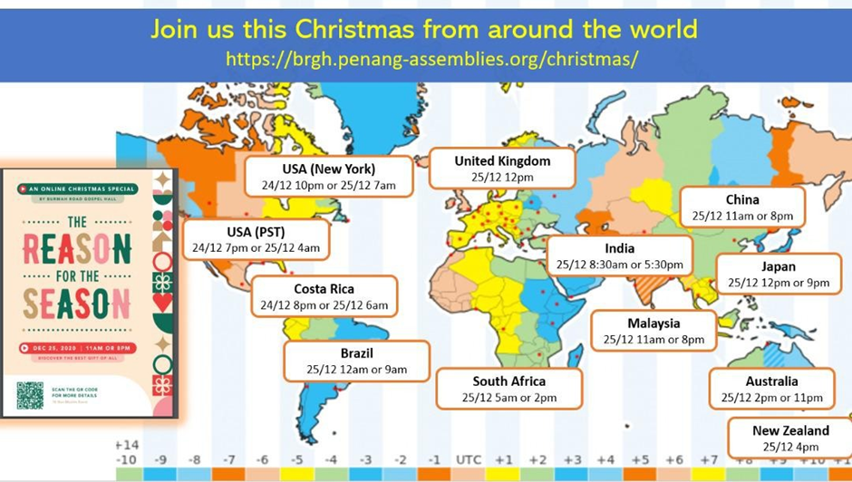
OR

