



22For Private Circulation Only. **Vol. 27** No. 3, (**25 Oct. 2023** from 11 Aug. 2023)

Website: [www.berita-bethel-ung.com](http://www.berita-bethel-ung.com) Email address:[beritabethelung@gmail.com](mailto:beritabethelung@gmail.com) **ΦΦΦΦΦΦΦΦΦΦΦΦΦΦΦΦΦΦΦΦΦΦΦΦΦΦΦΦΦΦΦΦΦΦΦΦΦΦΦΦΦΦΦΦΦΦΦΦΦΦΦΦΦΦΦΦ**

*My* ***F****aithful prayer partner/s in the* ***F****aith and in the defence of the Gospel* (Phil. 1:5, 7)

**W**ow, what a **W**eek or may I say, What **A Motley Month**!

Let me start with the month. Yes, it was a month ago, that I was down with ‘flu and a bad cough that rendered me weak and restless forcing me to lie in bed most of the time despite the fact that a month before that my wife and I just had our regular annual anti-flu jab. That bout with the ‘flu caused us to be absent from the Lord’s Supper for two Sundays for fear of our presence in the meeting might infect others.

But just a week before that both of us had to leave the Lord’s Supper early, just as thanksgiving was made for the elements as my wife felt turmoil in her tummy while I felt my head spinning (because of my hypotension). We had to leave even before we could take of the bread and wine just to arrive home in time for my wife to ease herself, and myself to sink into bed. This was the first time we ever had to do this. The Lord forgive us!

But it was great that all these happened at that time because on 12th October (a few days later) we had to take the Aeroline Bus to Kuala Lumpur at the invitation of our daughter to have a taste of condo-living in our grandson’s vacant condo at South Brooks, Desa Park City as Daniel had a bank scholarship to do a MBA programme at Oxford University; while his wife, Alicia who was accompanying him, secured a post as a Library Assistant at the Bodleian Library also at the University.

Condo living was a new experience for us. We enjoyed the very environment-friendly spaciousness of the parks with greens, sunshine and water around us and the friendly community of seniors, youths, children, locals and foreigners and above all, the pet-friendly surroundings. We had the opportunity to see various breeds of well-groomed dogs, small and big, being walked or carried along in perambulators and well-treasured as babies of their owners. Yet, as we enjoy the pups, we never saw their poops! It was a paradise for pets indeed!

Of course, there are also the usual amenities as swimming pool (and what a unique size and shape bordered with fringes of grass, so different from the regular staid-shaped concrete-paved ones we usually see), gym, etc. etc. and of, course the panoramic views all around us from the roof-top. Yes, it has its attractions and beauty but it also has its problems.

All the structures and alley ways are almost of identical design. On the first day, we were lost as we struggled and failed to unlock with a key the door of a unit of the same number and floor as ours. We were at the wrong tower block! Another limitation was the two access keys one unit is entitled to. It was troublesome to pass the key from one to another for use.

And of course, every time we needed to go out, we had to travel the distance to the car park to get to the car. If we need to do this a few times during the day, it could become problematic especially for seniors like us, so used just to open the door and step out!

On the Lord’s Day, while my daughter and her husband went to their church, my wife and I visited the assembly of our dear friend, Leonie at Sri Damansara Gospel Centre. It brought back sweet memories of the time when I was invited to teach the Word in the assembly. It was a good time to meet up with the faithful saints there as well as later with an elder of Kepong Gospel Hall and one dear brother from Australia visiting his old assembly. After her morning activities, sis. Leonie brought together a few senior members and we had a wonderful lunch reminding us of the old times and recollecting the Lord’s blessings.

The next day, we got ready to go for a rest at Cameron Highlands. We passed through Bentong to view Bentong Gospel Hall. I could hardly recognise it from what it was during its pioneer days.

My daughter, a retired Bank Negara executive, managed to rent the bank bungalow for our use. My wife’s sister and her husband from New Zealand also joined us. We had a very restful time together. The occasion also served as a partial family reunion though we missed our two sons and their families who were abroad with their business and travels.

One event that stood out in our stay at Cameron Highlands was the coming together of us all to give God thanks for the **twenty-seven** years (since 16th October, 1996) of His Call for me to go out to serve Him in a teaching ministry. We had a steam-boat dinner in Cold Camerons.

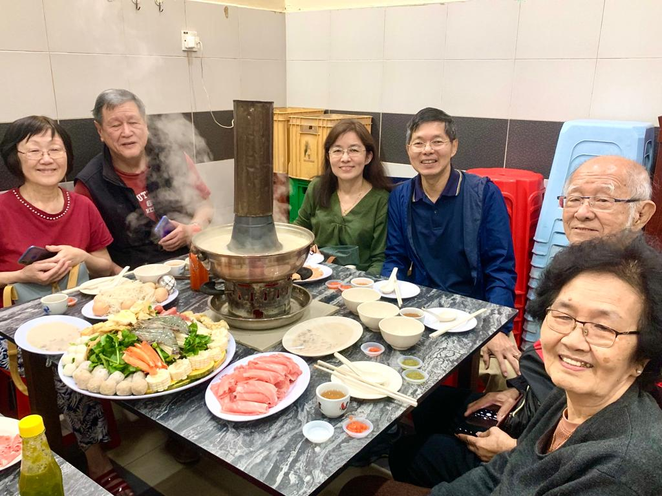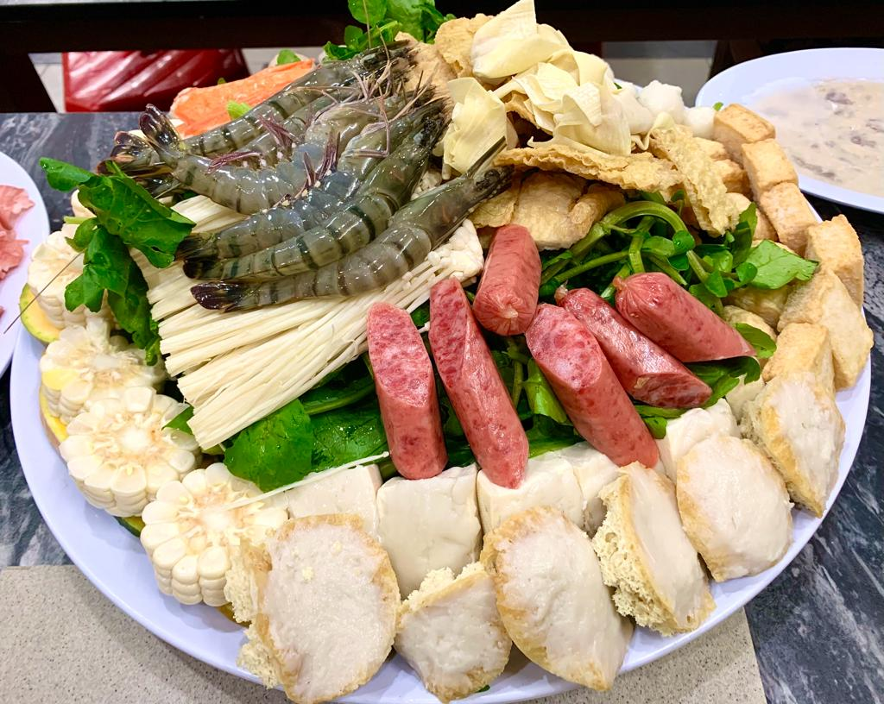

Later, I had the opportunity to relate to those present how the Lord called me to serve Him thus. For those interested, the full account can be found on my website: <https://www.berita-bethel-ung.com/webcontent/Oct162021-UKC-BRGH-My-Call-Commission-and-Commendation-Silver_Anniv.doc>

As I recollected this important day in my life, I highlighted certain events that occurred in my ministry of 27 years to the Lord as a reminder to me of His Call, Commission, Commendation and thereafter His Promises to Provide and Protect me as I serve Him along the way.

Firstly, My Call -What It Is. It is Based on .......

Luke 4:24 - *No prophet is accepted in his own country –* therefore I need to go out from my home.

Luke 4:43 - *I must preach the kingdom of God to other cities also; for therefore am I sent*.

This I did. In my ministry the Lord had opened His doors for me to preach and teach the Word in Sabah, Singapore, Myanmar, Cambodia, Vietnam, Indonesia, India, Australia, America…

Next, the Lord’s Commission: (Yes, I would like to remind myself of this always).

Luke 10:4 - *Carry neither purse, nor scrip, nor shoes: and salute no man by the way.*

Luke 22:35 - *And He said unto them, When I sent you without purse, and scrip, and shoes,*

*lacked ye any thing? And they said, Nothing.*

And I too would repeat aloud, “Nothing!” I can testify to this as never did I ever ask for a “salary” or a sen to support my ministry or to supplement my travels. The Lord just supplies and provides as He deems fit through various saints and sources without my asking. This can be consistently and concretely illustrated to by an anonymous saint who put in a token gift in a HSBC envelope earmarked for me in the assembly offering bag every month these 27 years (COVID or no COVID) without fail since my commendation until now! Thank you, brother or sister, whoever you are. The Lord bless you with multiple returns of His riches in high places.

As I pointed out at the beginning, this term was a mixture of gladness and grief. Within the time frame of just three months, I lost over ten dear friends I grew up with, missionaries I worked with and students of my Bible classes I taught from near and far. Below is a diary of such people who have been called to be with the Lord whom I hope to meet as the Lord deems fit when my turn comes…

|  |  |  |  |
| --- | --- | --- | --- |
| **Date** | **Name** | **Where** | **Age** |
| 19 July, 2023  (28.06.1934) | **Peter Ferry** | In Phuket | 89 |
| 29 July, 2023 | Teoh Siew Mooi  (Mrs. Raymond Goh) | BMGC | 61 |
| 04 Aug. 2023  (20 Feb. 1925) | Leong Yoke Wan @Chan Kum Lan | In Petaling Jaya | 98 |
| 15 Aug. 2023  21 Nov. 1931 | **Rev. Dr. U Tin Maung Tun** | In Myanmar | 92 |
| 11 Sept. 2023  20 May, 1941 | Chin May Yoke | In Kepong, KL | 82 |
| 14 Sept. 2023  11 Mar. 1935 | **Low Kim Leng** | In Penang | 88 |
| 22 Sept. 2023  28 Apr. 1941 | **Alan Choong Khoon Lik** | In Kepong, KL | 82 |
| 6 Oct. 2023 | Cecelia Chuah | In Ottawa |  |
| 6th Oct. 2023  12 Aug. 1937 | **Ooi Joo Tin** | In Penang | 86 |
| 7th Oct. 2023  6th Feb. 1945 | Dr. Choong Yoon Tet | In Sydney | 78 |
| 15th Oct. 2023  18th Oct. 1937(?) | **Chee Swee Foo** | In Shah Alam | 86(?) |

Until we all meet again, I thank the Lord for this glorious hope that while I may not see the above saints now, or meet you, loving brothers and sisters in the Lord so close in partnership with me this day, I look forward to that day when we shall meet each other again in the presence of the Lord if our paths do not happen to cross. Amen.

Coming back to the present, I would like to inform the former saints who gathered at Burmah Road Gospel Hall and who still love this present assembly as I do, I have started a three-part series on the **History and Heritage of Burmah Road Hall** since its early days. Part I was entitled, The Buildings, Part II, the Builders and Part III, The Binders. Part III will be delivered on 26th November, 2023.

Parts 1 and 2 are already on my website: [www.berita-bethel-ung.com](http://www.berita-bethel-ung.com).

Please visit it if you want to relive happy memories of those times when you were in fellowship with the saints there and then.

Before I conclude, perhaps I may include another coming thanksgiving event due to take place at the end of the year. I refer to God’s amazing Grace bestowed on my wife and me keeping the two of us ever loving one another and ever living for Him all these years as we celebrate our diamond wedding anniversary at the end of the year. God has been good seeing us through all these years despite our individual and personal idiosyncrasies, and through those relatively hard times when my wife had to manage the family affairs all by herself with myself transferred and posted out-station nominally to serve the government, but in actuality to serve God’s Purpose and God’s People in Temerloh. Yet in spite of these problems, He brought us back together on May, 1st 1969 just before the notorious May 9 riots. And thereafter to protect and provide for our three children as they grew up and flew the nests. leaving the two of us to “fend” for ourselves, and yet never alone, because the Lord was with us and the children ever so faithful to God and to us. The Lord indeed is Good and Gracious. Even as the family members Gather together at the end of the year as we expect to (DV), we can only proclaim “*Ebenezer*” as we memorialise this diamond year!

My family and I also thank all of you for being faithful partners with us in the service of the Lord in the family of God all these years. Thank you and God bless all of you.

**To God be all Glory.**

==================================================================