



For Private Circulation Only. **Vol. 28** **No. 1** (**03 Feb. 2024** from 25 Oct. 2023)

Website: [www.berita-bethel-ung.com](http://www.berita-bethel-ung.com) Email address:[beritabethelung@gmail.com](mailto:beritabethelung@gmail.com) **ΦΦΦΦΦΦΦΦΦΦΦΦΦΦΦΦΦΦΦΦΦΦΦΦΦΦΦΦΦΦΦΦΦΦΦΦΦΦΦΦΦΦΦΦΦΦΦΦΦΦΦΦΦΦΦΦ**

*My* ***F****aithful prayer partner/s in the* ***F****aith and in the defence of the Gospel* (Phil. 1:5, 7)

So **F**ast, So **F**leeting! One month of the new year has **F**lown past! And now we are already in the **F**irst **F**ew days of **F**ebruary. Soon, we shall come **F**ace to **F**ace with Chinese New Year which **F**alls on 10 **F**ebruary.

The Passing term was very eventful for me with one Memorable and Monumental event to highlight and another Painful Period that I experienced not to my delight. The former brought back Memories of 60 years of Marriage Bliss between my Beloved wife and me as our family of three children and five grandchildren came together physically and virtually to celebrate our Diamond Anniversary last December.

And, wonder of wonders, I was able to re-enact that memorable day with me in my original marriage suit of sixty years ago to propose to my beloved wife with a diamond ring as we renewed our marriage vows, singing our marriage hymn giving the children and grandchildren a glimpse of what happened that day that made it possible for them to witness what was happening before their very eyes today, as their potential parents sang together:

*I've found the pearl of greatest price Eternal life so fair*

*'Twas thro' the Saviour's sacrifice I found this jewel rare*

*I've discovered the way of gladness;*

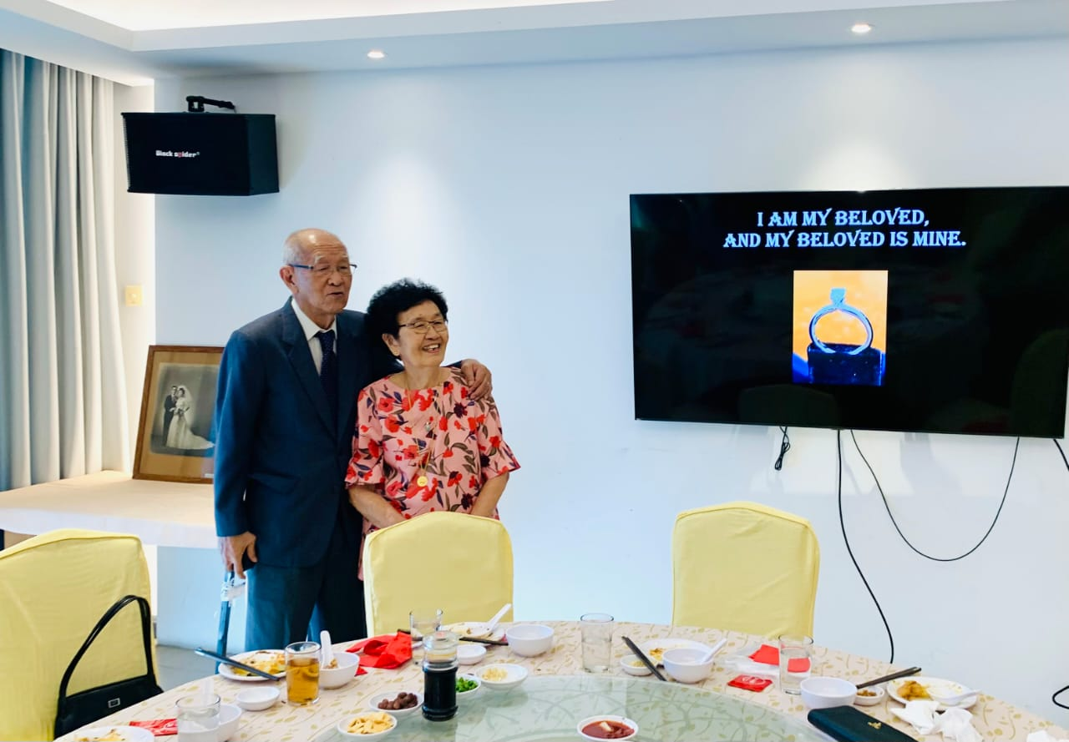

*I've discovered the way of joy*

*I've discovered relief from sadness*

*'Tis a happiness without alloy*

*I've discovered the fount of blessing;*

*I've discovered the living Word*

*'Twas the greatest of all discoveries*

*When I found Jesus my Lord.*

It was so Lovely and Livingly so real when we could (this time with our family around) to witness this Past Picture re-enacted in Present time for our Posterity to see for themselves how their Parents came together to give birth to their being! As we sang, we recalled these lovely and meaningful words that had sustained us in wedded bliss all these lovely and loving years for the two of us. Indeed, both of us had found our Precious Pearl in our Lord, and in each of us, all these pearly years. To Him be all Glory Who has made all these things Possible.

Well, these Precious Pearly years are not without their accompanying aches and pains as we age with the years. This was the Painful Period to come. As we age, our bones and muscle ache too. I accepted a loving massage offer to right my aching bones. But alas, it aggravated the old muscles instead and caused stiffness and muscle aches to set in to the neck, shoulder, arms, back, thighs, calves and feet that I had to consult an osteoporosis consultant leading to a month of physiotherapy sessions as I could not bend, lift my arms or turn my neck. Today I am better but still stiff in these affected parts.

Both of us will soon be celebrating in name our late eighties this month – another monumental month when we invite not only our children (who were not even present when both my wife and I celebrated our birthdays for the first time together) but also the whole world virtually to celebrate mine – and a couple of weeks later my beloved’s!! A bit Puzzling? Pardon me then because it is intended to be so but no Prize is given for solving the Puzzle!

This year is the Year of the Dragon. It is regarded as an auspicious and prosperous year by the Chinese. However, biblically and prophetically it is not going to be so, and we already have an insight of what the world is going to be commencing with the events that happened on October 7th in Israel last year… and after that, on to this year with a forecast that is going to be worse as we study the prophetic scriptures.

And I am thankful that I have the privilege to study it from a biblical perspective at my home assembly (Burmah Road Gospel Hall) this year. This is a repeat study of what I did 12 years ago in other assemblies but not at BRGH because they opted out of the series then. I am indeed touched that they have invited me back this year to do the study. Anyway, all my Chinese New Year Animal studies can be found at my website at <https://www.berita-bethel-ung.com/messages.html> for those interested. By the way my first study of the Chinese New Year Animal series was that of the Pig in **1983,** over 40 years ago and since then every year without fail studying each animal in turn biblically.

But as my wife and I do so, adding an additional year to our respective age, as is the Chinese custom every new year, we cannot run away with the pains and aches that accompany each age as they pass us by. Both my wife and I are feeling the ravages of ageing, creeping up on us as we welcome each new year. Today, my wife needs support as she walks and aids to hear people talk. But on the whole the Lord has been good to her to enable her still to do what she can within her limits – and, that’s good because it enables her to be on her own within her limitations.

Likewise, my ministry for the Lord is curtailed within limits, being not able to drive long distances to visit assemblies and at night to attend meetings. I need to keep a check regularly on my procedural hypotension and breathlessness. Other than that, I thank the Lord that he still gives me a fertile mind to be involved in mental spiritual activities for Him.

Assemblies still invite me to do some of the deeper doctrinal and devotional studies of the Word, illustrating them with Powerpoint slides, outlining these messages systematically for recording and preservation for future reference in my website at [www.berita-bethel-ung.com](http://www.berita-bethel-ung.com). Today, I still contribute to the daily devotions of Folio Press Choice Gleanings, and I still write my weekly Lord’s Day Ruminations for meditation for the Lord’s Supper.

**Rumination 1000** will appear on **24th March 2024, nineteen years** after Rumination **No. 1**

**(27th February, 2005)**!

The Ruminations were written particularly with the Lord's Supper in mind or some biblical passage text as its theme.

By March, there will be **1000** outlines for rumination stored in my website, at <https://www.berita-bethel-ung.com/ruminations/indexofruminations.html>

At this point, and as I age (87 this year), my physical and mental faculties are not functioning as well as they did nineteen years ago. On 24th March 2024, I would have written my **1000th** Rumination without fail every Lord's Day since the first which appeared on 27th Feb. 2005.

Every one of these Ruminations is original, with the Lord sharing His thoughts with me for me to share them with His people.

Since then, many assemblies (owing to the poor participation by brothers in the main meeting) have introduced devotions to be read at the commencement of the Lord’s Supper to set the tone for the meeting. However, there is one big difference between this and my rumination. What is read out in the devotion is mainly the author’s thoughts, whereas my Rumination consists of only Bible texts, themes and thots for the believers to meditate upon as led by the Spiri! I only give the “bones (or skeleton)”, the believer has to wait on the Spirit to supply the “flesh”!

However, concerning this matter, I am seeking the Lord’s Will as to whether I should continue.

I am now open to a number of options as follows. Should I…

1) …carry on with what I am doing every week going beyond the 1000 mark?

2) …stop at Rumination 1000? – To take a rest after 19 years of Regular Ruminations.

3) …continue to write but do it twice weekly?

4) …recycle the 1000 ruminations making any modifications where necessary?

5) OR if you have any other suggestion please let me know.

Yes, if you, dear brother/sister can give me your feedback. I shall truly value it. Please come back to me by the end of February replying to this email or WhatsApp me at 016-4961938.

This year I shall be more busy than last year but still limiting my ministry to assemblies on the island. Herewith my programme:

|  |  |  |
| --- | --- | --- |
| February | | |
| 4 | X X X | Rest Week |
| 10 | Saturday | Chinese New Year |
| 11 | BRGH | The Year of the Dragon |
| March | | |
| 10 | SAGH | Series to be decided later |
| 17 | SAGH | Series to be decided later |
| 24 | X X X | Rest Week |
| 31 | SNGH | Resurrection Sunday – Why is the Resurrection important and What it accomplishes. |
| April | | |
| 28 | BRGH | Topic to be decided later |
|  | | |
| May | | |
| 1 | SAGH | **25th Anniversary of SAGH** |
|  | | |
| June | | |
| 9 | SNGH | The Future Judgements Part 1 – The Judgment Seat of Christ |
| 16 |  | Father's Day - |
| 23 | SNGH | The Future Judgements Part 2 – The Judgment at the Great White Throne |

Finally, even as I bade farewell to a number my cotemporary brothers and sisters who were called home to be with the Lord last year (see last year’s Berita), let me conclude this Berita with a final farewell to sis. Ivy Khoo Gim Cheok (in the middle in the baptism group photo) who was baptised together with me at Burmah Road Gospel Hall on 22nd October, 1950. With her homegoing, all who were baptised with me on that day, viz. Hugh Tan Choo Yew, the Mong Sisters Swee Kam and Swee Chan (together with Dr. Don Nicholls and Mr. Sidney Adams) and now Ivy Khoo, have all been summoned home to heaven, leaving me as the lone ranger here perhaps to complete the Lord’s task which He has commissioned me to do and which I have yet to complete (?) They are all enjoying their Rest and Rewards and the Blessings of the Lord. I have to wait my turn!

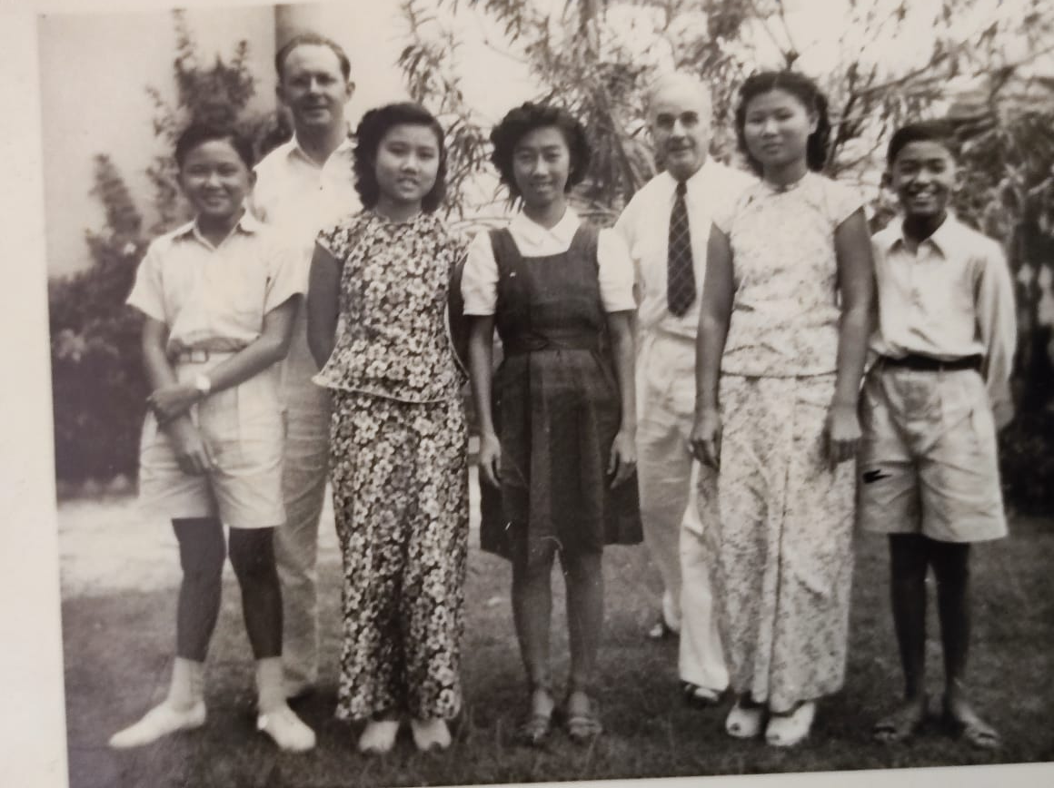



As I conclude, my wife and I would like to take the opportunity to wish our children, grandchildren, and our faithful partners and friends

***A Blessed and Bountiful Chinese New Year***

***With Much Peace and Prosperity (Josh. 1:8; Psa. 1:3) in the Coming Year.***

***If at all Biblically Possible knowing that it is high time to Awake out of sleep***

***seeing what is happening around us now especially in the Holy Land!***