



For Private Circulation Only. **Vol. 28** **No. 3** (**6 August, 2024** from 24 Mar.)

Website: [www.berita-bethel-ung.com](http://www.berita-bethel-ung.com) Email address:[beritabethelung@gmail.com](mailto:beritabethelung@gmail.com) **ΦΦΦΦΦΦΦΦΦΦΦΦΦΦΦΦΦΦΦΦΦΦΦΦΦΦΦΦΦΦΦΦΦΦΦΦΦΦΦΦΦΦΦΦΦΦΦΦΦΦΦΦΦΦΦΦ**

*My* ***F****aithful prayer partner/s in the* ***F****aith and in the defence of the Gospel* (Phil. 1:5, 7)

**Wow! Wow! Wow! ... Wah! Wah! Wah!**

No, they are not barks of an unfriendly dog, nor are they the cries of a hungry baby.

They are Cries of Exclamation and Excitement at the Amazement of the Wonderful Grace of God as I stand in Awe at what God has been doing in my life recently.

**The first and most recent Wow!**

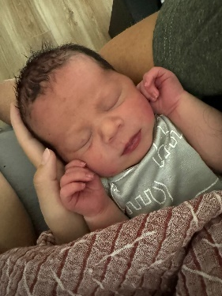On Monday, 29th July at 7.12pm. (US time) or Tuesday 30th July at 7.12am. (local time), I was resting at the observatory at Gurney Bay after my walk in the park to watch the sun rising from the horizon, my usual practice. However, that morning the sunrise was covered by the clouds. I was disappointed. But then at that precise moment, I received a WhatsApp phone notification, and the message was precise and to the point: “**The Baby is Born**!” from my granddaughter, half the world away, announcing God’s gift to her sister. It was precisely the time of the rising sun as I confirmed it the next day when I saw the bright round red ball creeping up slowly from the horizon, as I would imagine Shiloh being delivered very lovingly from the watery home that had been the baby’s residence for nearly nine months in the mother’s womb.

**Wow!** With the baby’s appearance also came the automatic promotion of all members in our respective families in my lineage. All have risen one rung in our family ladder. My son and his wife are now grandparents and my wife and I are now Great-Grandparents – **Wow!**

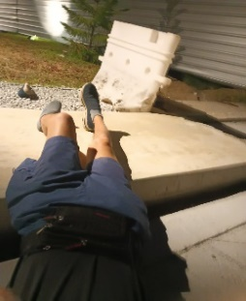

The next would be a **Wah.** It also occurred at Gurney Bay on the other end of the park. It was on Friday, 24th May at 6.20a.m. The sky was still dark but the park was fairly-lit with lamps all over the place. However, it made no difference in the height between the pavement and the road of similar cement colour. I did not see the 4-inch difference in level, I tripped! And I flew! – leaving one shoe where I was standing a moment ago on the road, and landed flat on my face on the pavement a few feet away!

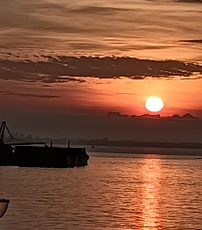**Wow!** It was the amazing grace of God that nothing seemed to have happened to me but just a humiliating fall of my pride with me lying flat on my front and face. Then I somehow managed to turn myself up to feel my face and limbs for injuries; there was none except the feeling of humiliation of a fall – no broken bones and no bleeding. So, I got up and walked another quarter mile or so to the observatory at the other end of the park to wait for the sun to rise. It was worth waiting to see the red ball creeping up from the horizon. After that I walked back home, none the worse, so it seemed, and so I thought, from the fall.

When I reached home, I looked at the mirror and saw purple bruises on my left cheek and a blood-shot left eye with a little dripping of blood from my left nostril – still none the worse and manageable on the whole.

Two days later, everything changed! **Wah!** My left-cheek was almost wholly blood-purple. My children insisted that I went for a medical checkup. My stubborn self obeyed. I consulted the ophthalmologist - my left blood-shot eye was not injured; I consulted my cardiologist, I had to stop taking my blood-thinner for two weeks. I consulted my orthopaedic surgeon who had me scanned from head to chest – no bone broken, not even a hair-line fracture!

On looking back, had I bled in my fall, I would not have any means to stop it as I was on a blood thinner. Had my bones been fractured I would not be able to walk home. I was alone. Only God was with me. **Wow**! It was a **M**iracle!

**Wow**, it was **M**arvellous! This term was a very busy term for my wife and me. Both of us are aging (I would reach a double eight figure next year) and would not be able to travel the world. But the world came to us. In the months of June and July, we had visitors from Sydney, Melbourne, Perth (Australia), Nelson (New Zealand), New York, Hawaii, Dallas (United States), Singapore and other local ones from PJ, KL and Klang. We were kept happily busy and feasting on the guise of fellowship with friends and relatives some of whom we have not seen for a long time. We are also thankful to a few local visitors who came to our home with their loving home-cooked or bought *tah-pow*” food for our consumption now and then. They also remembered us during festival time and my wife and I are indeed grateful to them for their love and concern for us.

**Wah!** it was also **M**ourning time. On June, 9th we bade farewell to my wife’s sister who was called home after more than ten years battling with Parkinson and finally succumbing to cancer. During this time, both my wife and I had to surrender her to four nursing homes as we were too handicapped to nurse her. However, we still cared for her in visiting her regularly and seeing to her additional personal needs all these ten years or more. It was not easy for both of us with our aging infirmities, but the grace of God was sufficient to enable us to do what we could for her. The Lord has finally relieved her of all pain and suffering. She is now resting in His loving arms.

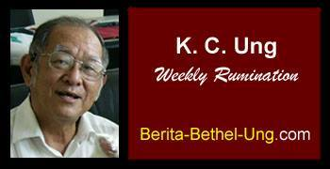

**Wow!** So I still **M**anaged to complete my 1000th Rumination and will be posting my 1020th next week, though I have stopped my Reflections for the Week. I feel that I still need to exercise my Mind and be active for the Lord in spite of my Age. I do not want to meet Alzheimer!

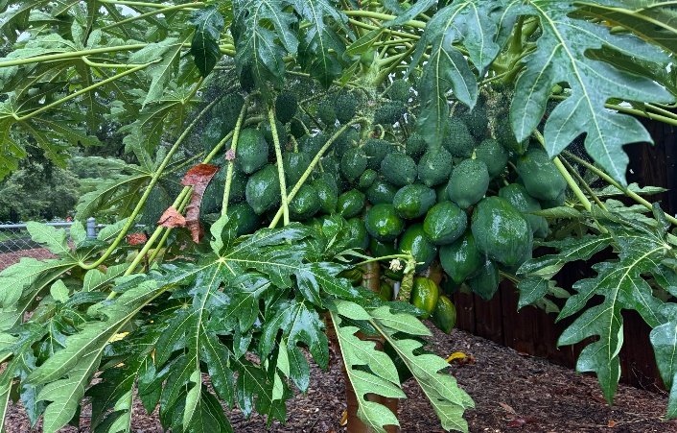**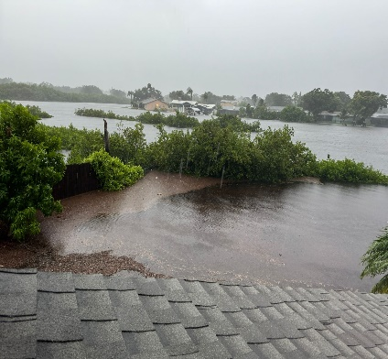Wah!** As I write this, I received news from my son in Florida, that Debbie, (a tropical storm) just visited his home at 4.30p.m. on Sunday and turned his backyard into a lake as well as brought down his fruitful papaya tree. Other than that, nothing serious transpired. **Wow!** By God’s Grace, people and property were safe. As for the papaya tree, it seemed that he would be able to revive it, and they will be able to enjoy its fruit in due season.

**Wah!** My Speaking **M**inistry for the last couple of years has been affected by Covid and Concern for me. I could not visit a few assemblies in Penang because of the disease, restricting movement during the epidemic period then and the distance to travel now. Ferries to Butterworth today do not transport vehicles! Also, these days I cannot drive that far to visit them and the assemblies on the mainland graciously leave me out in their preaching roster.

The last time I was in Bukit Mertajam Gospel Centre was on 11 July, 2021, and the last occasion I spoke in Butterworth Gospel Hall was on 12th June 2022. And it does not look like this is going to change. Incidentally, I have also not spoken at Island Glades Gospel Centre since 9th October 2022.

However, as for Sungai Nibong Gospel Hall, my last speaking engagement there was on 13th June, 2021. Then they discovered that I was still ministering at Sungai Ara Gospel Hall regularly though a longer distance away. Thus, I was glad that in spite of my limitations I could still be of service to the saints there when they invited me back to speak on Father’s Day on June 18, 2023 and since then I am on their regular roster. I could still do this because they are on the island.

My **M**inistry engagements till the end of the year:

|  |  |  |
| --- | --- | --- |
| August | | |
| 25 | BRGH | The Vision of Joshua the High Priest, Zech. 3 |
| September | | |
| 8 | SAGH | Paul's Farewell to the Ephesian Church |
| 22 | SAGH | Faith in the Faithful God (A Reflection on the Golden Anniversary of SAGH) |
| **November** | | |
| 24 | BRGH | The Two Kings - Absalom and David, Compared and Contrasted |
| December | | |
| 1 | SNGH | Mark 13 |

**Wow and Wah!**

My wife and I definitely value your prayers for the two of us as we step past our mid-eighties with myself looking towards a double eight next year. My prayer then, as with Elisha, is to have a double portion of the Lord’s blessings upon my wife and I as we seek to cope with the physical, mental and spiritual challenges which are sure to encounter as we go forward in our walk with Him – for all that we know we may even be facing them now.

Again, thank you for your fellowship and prayer as we seek to serve the Lord where we can and where He enables us to. And thank you for your support in times like these.