



For Private Circulation Only. **Vol. 28** **No. 4** (**16 October, 2024** from 6 August)

Website: [www.berita-bethel-ung.com](http://www.berita-bethel-ung.com) Email address:[beritabethelung@gmail.com](mailto:beritabethelung@gmail.com) **ΦΦΦΦΦΦΦΦΦΦΦΦΦΦΦΦΦΦΦΦΦΦΦΦΦΦΦΦΦΦΦΦΦΦΦΦΦΦΦΦΦΦΦΦΦΦΦΦΦΦΦΦΦΦΦΦ**

*My* ***F****aithful prayer partner/s in the* ***F****aith and in the defence of the Gospel* (Phil. 1:5, 7)

**Ebenezer! Hallelujah! Soli Deo Gloria!**

[This is an interim report of certain urgent items that happened the last two months.]

**Ebenezer! (I Sam. 7:12)**

I am writing this today on the **28th Anniversary** of my Home Assembly (Burmah Road Gospel Hall)’s **Commendation** of me into the Lord’s Service - to go out of my home assembly to serve other assemblies. Thus, I continued with my original teaching ministry to the other assemblies (this time with their blessing) on the island of Penang and Province Wellesley, (Butterworth, Nibong Tebal, Bukit Mertajam), Peninsular Malaysia (Taiping, Kamunting, Ipoh, Bidor, Kampar, Kuala Lumpur (Jalan Imbi, Petaling Jaya, Ampang, SS2, Sri Damansara, Gasing), Cameron Highlands, Malacca, Mentakab, Temerloh, Kuantan, Kota Bahru, Seremban, Klang, and elsewhere). I have also been invited to minister to assemblies in Sabah, Singapore, Thailand, Vietnam, Myanmar, India, Australia, United States. And in every single case, the Lord provided the means.

**Jehovah Jireh! (Gen. 22:14)**

I was born 88 (double eight!) years ago next year, and born again on 17th September, 1950, baptised on 22nd October, a month later at the age of 13. This means I have been a Christian for 74 years already! And what have I discovered – He is my **Ebenezer** **(I Sam. 7:12)**, *hitherto*, *the Lord has helped me* and never failed me, not only me, but also my wife, my three children and their spouses, my five grandchildren (all have come to know the Lord and are actively serving Him) and a great-grandchild with the prospect of another one next year.

But the Lord is not the only Companion to walk with me all the way, I also have my wife (with me for over 60 years) to encourage and to stand by me whenever I am down, and to accompany me when I feel discouraged and disheartened; as well as concerned children to give me their grown-up matured counsel and up-to-date advice whenever I needed guidance to live out this very paradoxical world with its modern problems; but above all, the Lord is there for me under all circumstances.

Also to encourage me are those of the Lord’s saints who remember me every year of my commended service and this year is no exception. And I would like to thank the faithful couple who have walked with my wife and me all these 28 years from the day they attended my commendation service until now – 28 years of close fellowship in the Lord, ever reminding me of my relationship with and responsibility to my Lord and Master all these years. **Hallelujah!**

And of course, the brother/sister who anonymously dropped in an anonymous gift in a similar white envelope every single month for all these 28 years and more without fail! Yes, this is all the Lord’s doing. Then again, the last term was nothing short of miraculous. **Jehovah-Nissi.**

My eldest son’s family lives in Florida in the Clearwater (Largo) area. When Miss Helene and Mr. Milton visited them this month, it was a wonder that Miss Helene just dropped in to say, Hello! to them by just flooding the floor and compound of their home and Mr. Milton, though **eye**ing their home, parted his whirling path to go sideways to the north and to the south, when he came near their premises, leaving an alley to my son’s home dry and untouched between the two whirling paths, drawing the waters away to the north and thrusting out the waters to the south as Mr. Milton twirled his dancing trot inland and then outwards –northwards and southwards leaving the path to my son’s home dry and untouched! It was what the authorities would call,

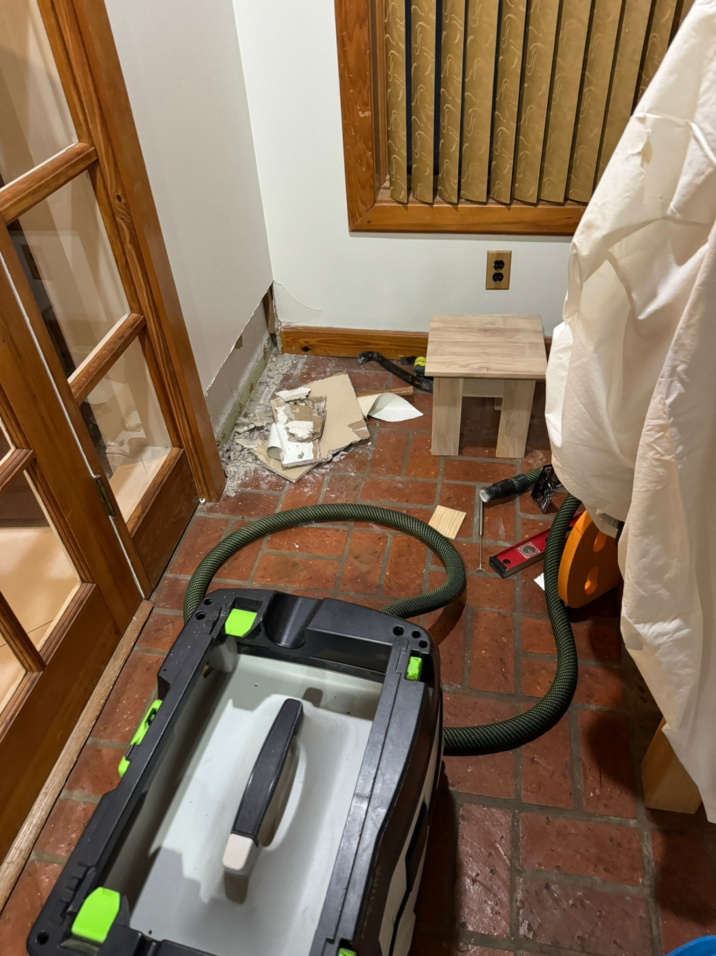

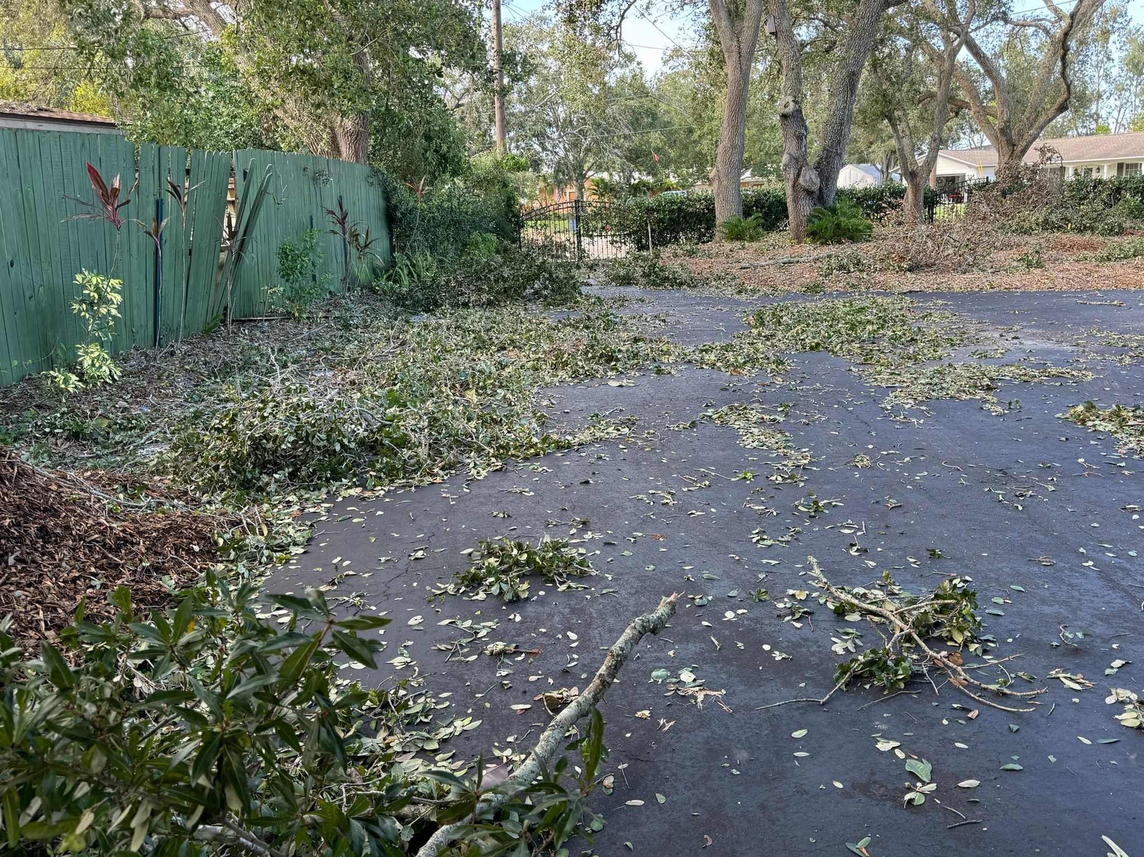

“**A Negative Storm Surge”!**

This perhaps would be reminiscent of how the Lord parted the Red Sea for the Israelites to pass through. It was indeed a miracle of the modern day that we were privileged to witness! We join him and his family to raise the banner – **Jehovah-nissi.**

While my wife and I, and our family were relieved for such a miraculous respite from the Lord, at the same time we were very grieved and sad to see the devastation and destruction of property and, even lives, brought about by Mr. Milton in his awful horrendous hurricane track. We could only wonder in awe and stand amazed at how the Lord saved my son’s family and property. Yes, we were humbled by the Lord’s mercy and glad for His grace, but we also grieved for our neighbours. Why it should be like this we will never know. We can just refer to God’s Grace, Mercy and Sovereignty. The Lord reigneth and He rules according to His will and purpose. **Hallelujah**.

Last season was also a time of sadness as we spent hours interceding for the needs of our beloved brethren who were facing life-threatening illnesses with a couple called home unto the Lord. We have been praying for a dear brother whose one leg had already been amputated, with the other one needing to as well because of his diabetic problems. Somehow that part of the second leg was not amputated high enough and alas a second operation had to be scheduled higher up. While recovering, his lungs were severely infected with pneumonia, and at the moment of writing the doctors had requested that his children be summoned to his bedside as soon as it could be done.

Oh, just received news that he had been called home to be with the Lord! **Jehovah Roh.**

Another doctor-elder of an assembly was in ICU for a number of days. His problems were complicated by liver and kidney failure and had to go through dialysis in his weakened condition. With undetected causes for his bleeding, it is indeed difficult for the doctors to treat him. Only the Lord can do so and all have to leave it to the sovereign will of God.

A couple from Australia are also requesting for prayers too. They are suffering from the effects of a post Pfizer Covid-vaccine and feel very weakened in the body. Somehow cases seem to show that the Covid-vaccine seems to have its bad after-effects. However, my wife and I have taken all the four injections with no symptoms accompanying them. And we are thankful to the Lord for this.

There is another over 90-year-old sister who loves the Lord dearly but somehow disagreed with the doctrinal stand of our assembly and left it years ago. She believes that the Lord can heal her without resorting to human medical help. She is now going through old-age symptoms and just trusting the Lord to heal her or do what is in His sovereign will for her.

Then we also have a request for prayer from a dear sister in Christ for her coming operation on 21st October because of lymph nodes in her neck which are malignant because of the spread of her previous thyroid cancer. Even as we pray for our sister, do join us to do so on her behalf as well.

There are a few more long-term cases which we would also leave to the Lord to heal according to His own sovereign time. We thank the Lord that in times like these their faith in Him is still strong and steadfast. Do join us to pray for them though many of you will not know them. All in all, let us continue to trust the Lord for He is ***Jehovah-Rapha****, the Lord that healeth thee.* Exodus 15:26.

As my wife and I bring the needs of our dear brethren to the Lord, both of us are conscious that we are not growing any day younger. With each passing day, we thank the Lord that His grace has sustained us for one day and strengthened us for another after a rest at night. But that’s where my wife’s problem further rests (!) – she has insomnia and does not sleep well at night. And with sciatica problems she has difficulty in her physical movements. But we thank God that she still has very sharp mental faculties to meet the challenges of modern living, though handicapped by hearing and vision loss in one eye.

As for me, though my physical movements are still good, I have arthritic stiffness and hypotension problems which limit my agility and mobility. Coupled with them, though I still have sharp vision yet it is marred by my drooping eyelids which affect my reading and typing on the phone or laptop. But I thank God that He has retained for me a good memory of His Word (captured in my young days) to help me minister it to others still. Thus, though I have written my 1000th weekly Rumination for the Lord’s Supper, I am glad that I can continue to do so to post my 1300th on Sunday.

I thank the Lord also that I can still continue to minister the word to the saints though in more limited now as:

|  |  |  |
| --- | --- | --- |
| **November** | | |
| 3 | XXX | Rest Week |
| 17 | X X X | Rest Week |
| 24 | BRGH | The Two Kings - Absalom and David, Compared and Contrasted |
| December | | |
| 1 | SNGH | Mark 13 |
| 22 | X X X | Rest Week |
| 25 |  | Christmas Day |

In all these developments in the last two months or so I can only end with:

**Ebenezer! Hallelujah! Soli Deo Gloria!**